Activity 12.5 Submission

1. Graphical user interface, text

   Description automatically generated with medium confidence
   1. Successfully opened the file in VScode
2. Graphical user interface, website

   Description automatically generated
   1. Screenshot of created database
3. Graphical user interface, text, chat or text message

   Description automatically generated
   1. Screenshot showing I navigated to the page to get my key and VScode showing my copied key.
4. Graphical user interface, application

   Description automatically generated
   1. Correctly started the real time database
5. 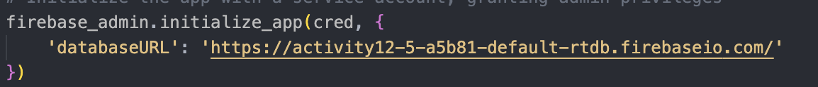
   1. Successfully updated the database URL
6. 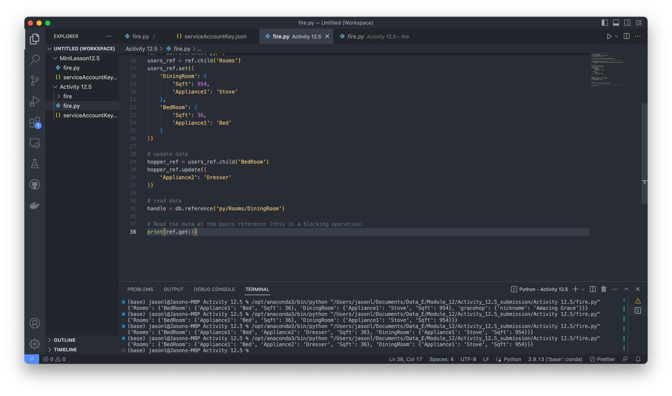
   1. Screenshot showing my code that I updated as well as it successfully running in the terminal below.
7. Graphical user interface, application

   Description automatically generated
   1. Screenshot showing updated and added entries in the real time database.